Student exercise 2

***This exercise to be done by the student in class***

1. Take class exercise 4 into consideration (Write a program to calculate factorial of given number). Change the code so that the program does the calculation with a number that the user enters. Class name should be FactorialDemo2

Output should be as follow:



1. ***A CAPTCHA (Completely Automated Public Turing test to tell Computers and Humans Apart) is a security measure used to determine whether a user is human or a computer program. CAPTCHAs typically involve presenting the user with a challenge or puzzle that is easy for humans to solve but difficult for computers to decipher.***

Taking your knowledge from previous exercises into consideration. Write a program to print random captcha. (Load two arrays with the alphabet. One array must contact small letters and the other array CAPITAL letters). Your class name should be captcha.

Output should be as follow:



1. Write a java program to create different classes for a dog and breed with methods and fill details. Main class name should be MainDog. The other classes should be Dog and Breed

The Dog class should have the following:

* Name (Set and Get)
* Age (Set and Get)
* Breed (Set and Get)
* Bark (Make the dog bark “Woof! Woof!)

The Breed class should have the following:

* Name (Set and Get)
* Country (Set and Get)

Output should be as follow:

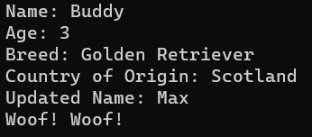

1. The following code calculate the area of two rectangles, by creating a method called get( ) to input values and calculateArea() to calculate the area.

Your mission is to change the code to accept (get) values from a users for one rectangle and then calculate the area from what the user has input. Your main class name should be TestTriangleNew.

Output should be as follow:

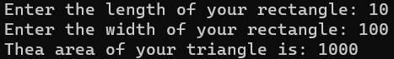

class Rectangle

{

int length;

int width;

void get(int l,int w)

{

length = l;

width = w;

}

void calculateArea()

{

System.out.println(length*width);

}

}

class TestTriangle2

{

public static void main(String[] ar)

{

Rectangle r1=new Rectangle(),r2=new Rectangle();

//create two objects

r1.get(11,5);

r2.get(3,15);

r1.calculateArea();

r2.calculateArea();

}

}